SECTION FF

CRANKSHAFT AND MAIN BEARINGS

CONTENTS

|  |  |
| --- | --- |
|  | Chapter |
| Removal and Dismantling .. | 1 |
| Inspection | 2 |
| Assembly and Fitting | 3 |
| Crankshaft Alignment | 4 |
| Crankpin Bore Sealing Cups | 5 |
| Fitting of Split Starter Ring .. | 6 |
| Special Tools.. | 7 |

CHAPTER 1

REMOVAL AND DISMANTLING

NOTE The following procedures are based on the assumption that the engine has been removed from its installation, and that all components above crankshaft level have been removed, including; coolant pump, engine camshaft, fuel pump camboxes, pistons and connecting rods, oil cooler, starter motors and sea water pump drive.

Removal

1. Bend back locking plate (3)(Fig FF.l), remove bolts (5), and remove the locking plate. Replace two diametrically opposed bolts to make the flywheel secure, and withdraw dowels (4). These are tapped Ml6 for withdrawal purposes.
2. Screw M20 eyebolts into the two tapped holes in flywheel periphery. Note that the holes close to the flywheel rim are reamed for fitting bolts and should not be used for lifting. Fit a suitable lifting sling and take the weight of the flywheel. Remove the 2 remaining setbolts and lift the flywheel away. In case of difficulty in removing flywheel use M16 jacking bolts in the two jacking holes provided.
3. Remove setbolts (2) and sufficient of the sump bolts to release drive-end cover (7). Remove cover complete with 'Vee' seal (12).
4. Remove torsional vibration dampers (Section FG).
5. Remove the free-end cover and sump (Section FH).
6. Invert the engine and place in a suitable stand or turn over frame.
7. Remove lubricating oil suction and delivery piping and the lubricating oil pump

(Section JC).

1. Remove the main bearing tie bar. Remove the oil baffle plate from the drive end main bearing cap (Section FH).
2. Using a hexagon bit, release and remove lateral capscrews (8)(Fig FF.3) and dowty washers (9).
3. Temporarily refit the tie bar to the main bearing caps to provide a stop for the reaction arm of torque multiplier. Using the multiplier, remove the main bearing nuts and plain washers.
4. Remove the bearing caps taking care that the bearing shells/thrust washers do not drop out and become damaged. If necessary crankcase expander (5)(Fig FF.3) may be used adjacent to any tight main bearing caps. Check whilst using the expander and withdraw the cap immediately it is free.

NOTE To avoid over expanding the crankcase a standard spanner of only 12 to 14 inch length may be used on jacking screw (5). Under no circumstances should an extension be used on the spanner. Maximum turning moment 108Nm (80 Ibfft).

1. Remove bearing shell locating keys (16)(Fig FF.ll) and centralising 'O' rings (15).

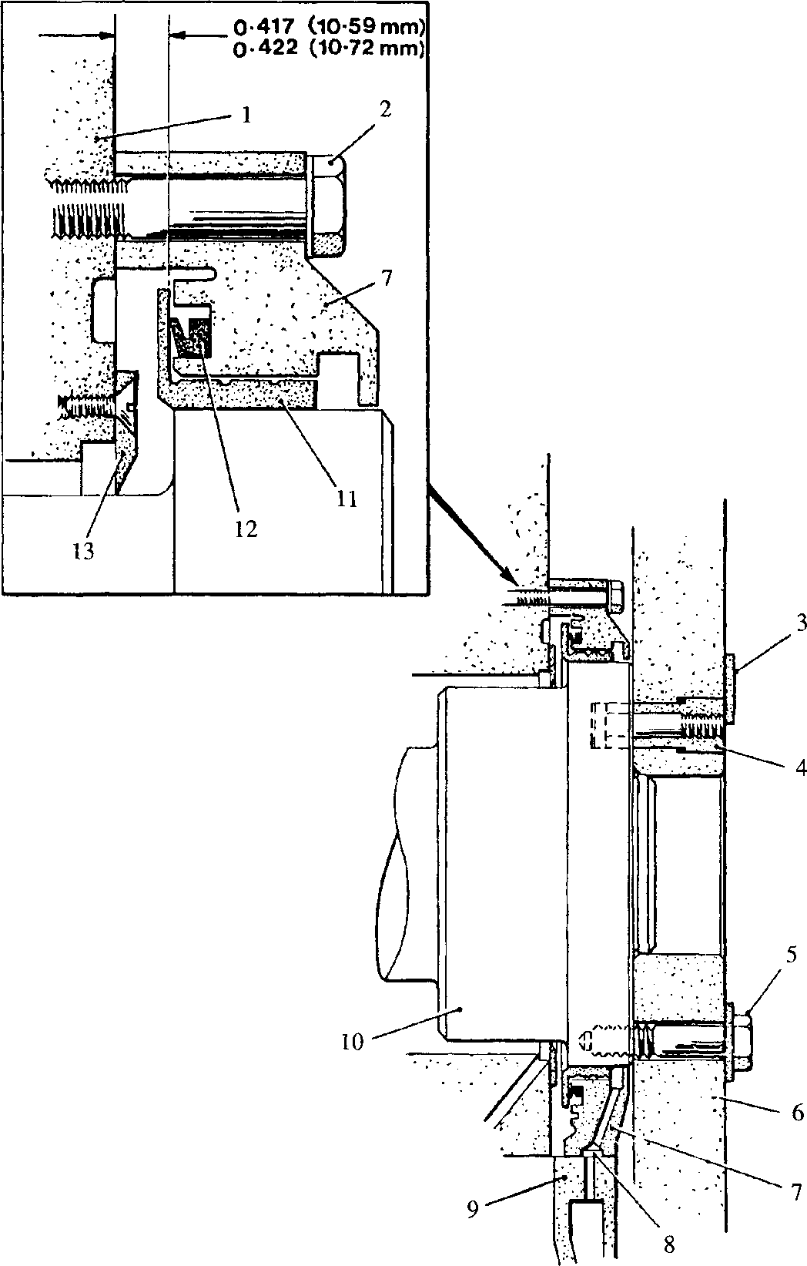

SPD00239

1. Drilling, oil drain to sump

Key to numbers.

1. Crankcase
2. Setbolt
3. Locking plate
4. Dowel
5. Setbolt
6. Flywheel
7. Drive-end cover
8. Sump
9. Crankshaft
10. Drive-end oil thrower
11. ’Vee’ seal
12. Oil sealing ring

Fig FF1 Drive end oil sealing and flywheel mounting

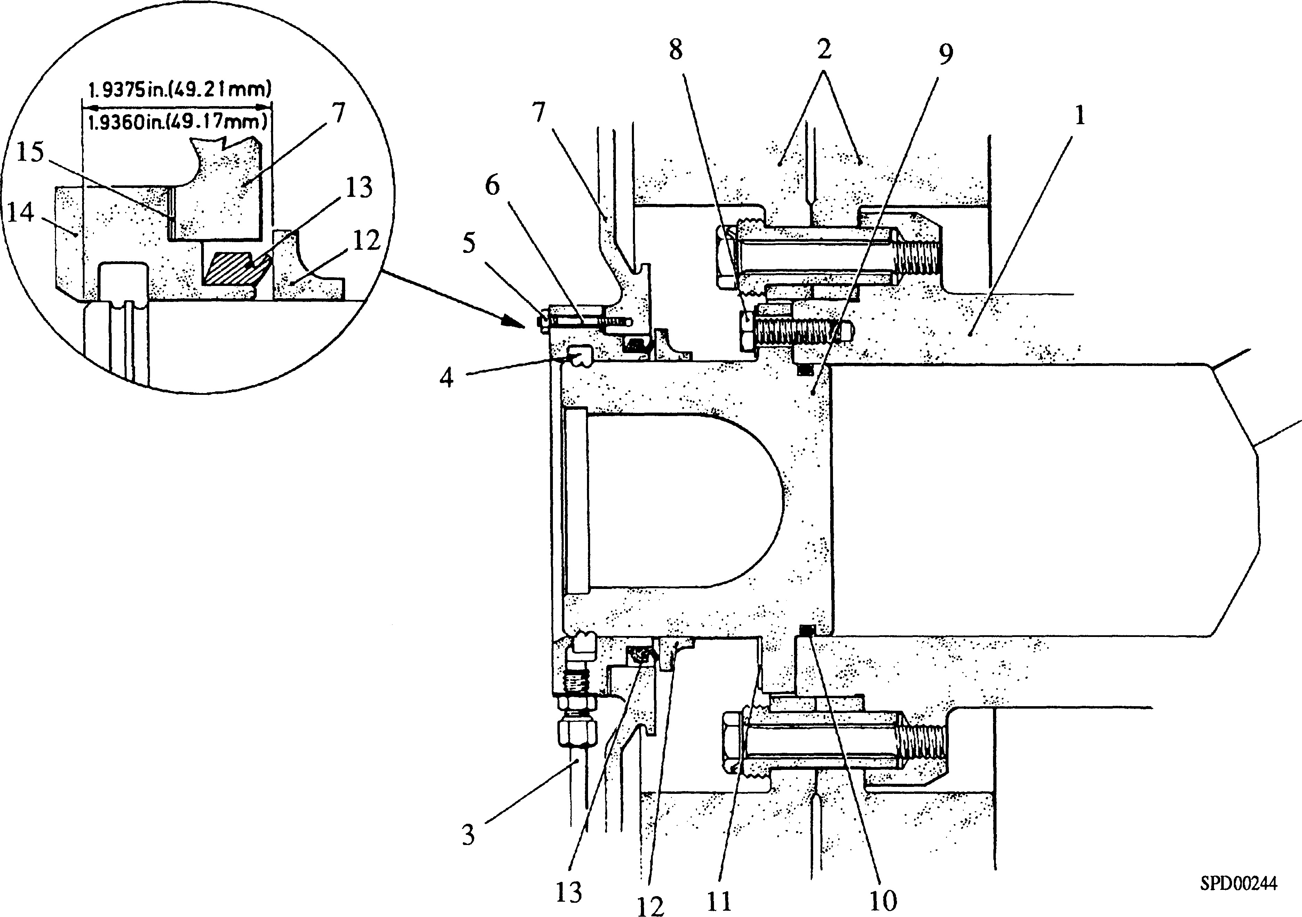

Key to numbers.

|  |  |  |  |
| --- | --- | --- | --- |
| 1. | Crankshaft | 9. | Stubshaft |
| 2. | Viscous dampers | 10. | 'O' ring |
| 3. | Oil drain pipe | 11. | Locking plate |
| 4. | Labyrinth seal | 12. | Facing ring |
| 5. | Philidas nut | 13. | 'Vee' seal |
| 6. | Stud | 14. | Seal carrier |
| 7. | Cover plate | 15. | Joint/shim assembly |
| 8. | Setbolt |  |  |

Fig FF2 Free-end stubshaft and oil sealing

1. Using turning out tool (Fig FF.4) remove all crankcase bearing shells EXCEPT the free-end and drive-end. The tool is used by inserting pin (2) into the appropriate journal oil drilling and rotating the crankshaft until bearer bar (1) contacts the end of the bearing shell. Further rotation turns the shell out of its housing.
2. Fit suitable pieces of rubber or plastic tubing to the free-end and drive-end main bearing studs to prevent damage to them or the crankshaft. Rotate the crankshaft to position Nos 2 and 7 crankpins vertical, fit a suitable rope sling and lift the crankshaft clear of the crankcase. Place in a suitable inspection cradle. Remove the remaining bearing shells from the crankcase.

Dismantling. (Fig FF.ll)

1. DO NOT remove balance weights (3) unless they are damaged or the crankshaft requires grinding.

Key to Numbers.

1. 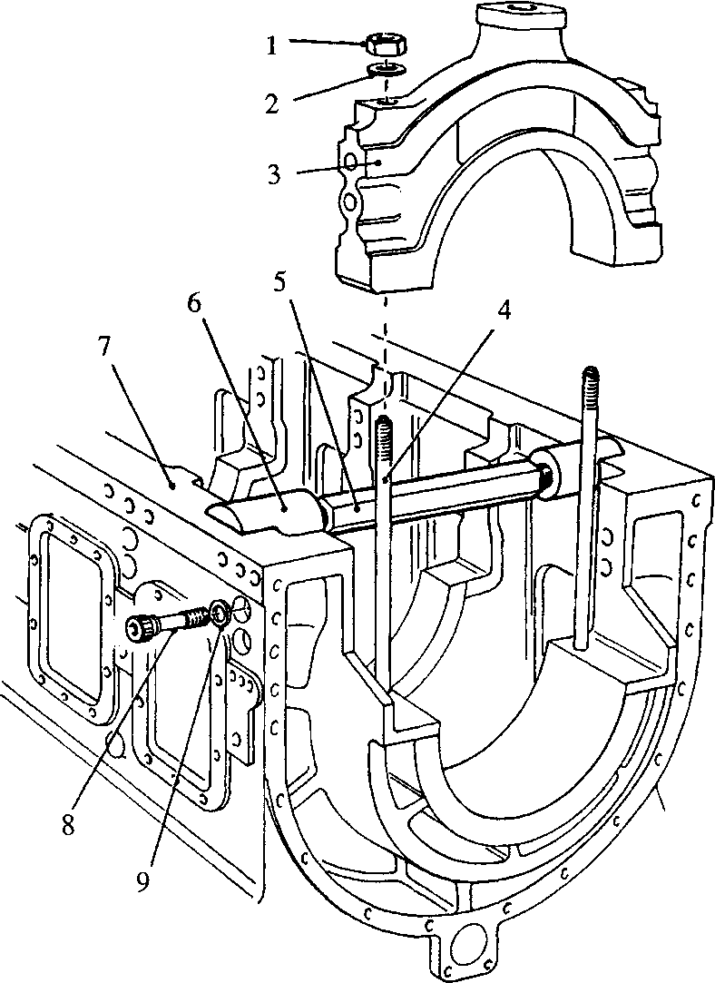Nut
2. Expander support
3. Crankcase
4. Lateral capscrew
5. Dowty washer

SPD00236

1. Plain washer
2. Main bearing cap
3. Stud for main bearing cap
4. Crankcase expander

Fig FF.3 Main bearing cap removal

WARNING IF THE BALANCE WEIGHTS ARE REMOVED THE CRANKSHAFT WILL HAVE TO BE BALANCED DYNAMICALLY AFTER RE-ASSEMBLY

1. Facing ring (20). There is no need to remove this unless it is damaged or badly worn. If this is the case, a hammer and drift should be sufficient to break it free from the 'Loctite' bonding with the stubshaft.
2. Stubshaft (23). Bend back the tabs on locking plate (22) and remove setscrews (21). Draw the stubshaft out of spigot engagement with the crankshaft using M16 setscrews in jacking holes (19) if necessary. Remove 'O' ring (24).
3. Drive-end seal (9). Remove capscrews (10) and withdraw seal from crankshaft. M8 tapped holes (36) are provided for jacking screws if necessary. Remove 'O' ring
4. and joint (11).

LIMITED RIGHTS LEGEND

5

USE, DUPLICATION OR DISCLOSURE OF THIS INFORMATION WHICH IS THE PROPERTY

OF GEC ALSTHOM DIESELS LIMITED BY THE U.S. GOVERNMENT OR BOLLINGER IS SUBJECT TO THE RESTRICTIONS SET FORTH IN DOD FAR SUPP 252.227-7013 (a) 15.

Key to Numbers.

1. 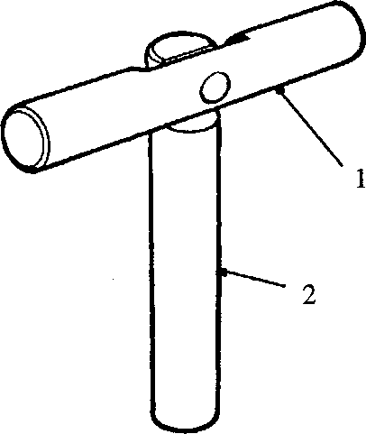Bearer bar

SPD00237

1. Pin

FF.4 Tool for turning out crankcase half bearing shell

Gearwheel (7). Using a crowfoot ring spanner slacken off philidas nuts (37), and with a pry bar force fitting bolts (34) back through the crankshaft until it is possible to remove the nuts. Force the bolts back until the heads can be gripped from outside the crankshaft, then withdraw the bolts and remove the gearwheel halves and dowels (6).

1.19

CHAPTER 2

INSPECTION

* 1. All dimensions, wherever possible, should be checked against the Schedule of Clearances and Wear Limits (Section CD).
  2. Clean the main bearing shells in a non-caustic solution and examine the bearing surfaces for scoring, wiping or cracking. Examine the locating dowels between the bearing halves for crushing. Check the bearing locating slot for fretting and burring. To establish main bearing wear, replace the shells in the crankcase in accordance with Paragraphs 3.8 to 3.16 inclusive.
  3. Clean the crankshaft in a non-caustic solution. A caustic solution will damage the free-end and drive-end oil seals, if still fitted. Examine the journals and crankpins for scoring, wear and ovality. Maximum permitted ovality 0.10 mm (0.004 in). Check the entire crankshaft for cracks using dye penetrant. The crankshaft is hardened by a nitriding process. Re-grinding is a specialist operation entailing re­nitriding after grinding. It is therefore recommended that the crankshaft is returned to these works for processing should re-grinding be necessary. Where this is not practical, details of the method for nitriding should be obtained from our Engine Service Department before it is undertaken.
  4. Check the balance weights for security. Examine all threads for serviceability.
  5. Check the condition of the gearwheel teeth. There should be no ridging, pitting, plucking, nor evidence of excessive wear.
  6. Oil thrower. Providing the oil thrower is not worn at the point of contact with the 'Vee' seal, and the 'Loctite' bonding with the crankshaft is leakproof (Fig FF.7) (see Paragraph 3.30), then there is no need to remove it, but it should be borne in mind that when the crankshaft is re-fitted the distance of the oil thrower to the crankcase must be as shown in Fig FF.l. There is no guarantee that new thrust washers will allow this to be achieved. To remove the oil thrower carefully cut through and break away from the 'Loctite' bonding.

CHAPTER 3

TO ASSEMBLE AND FIT

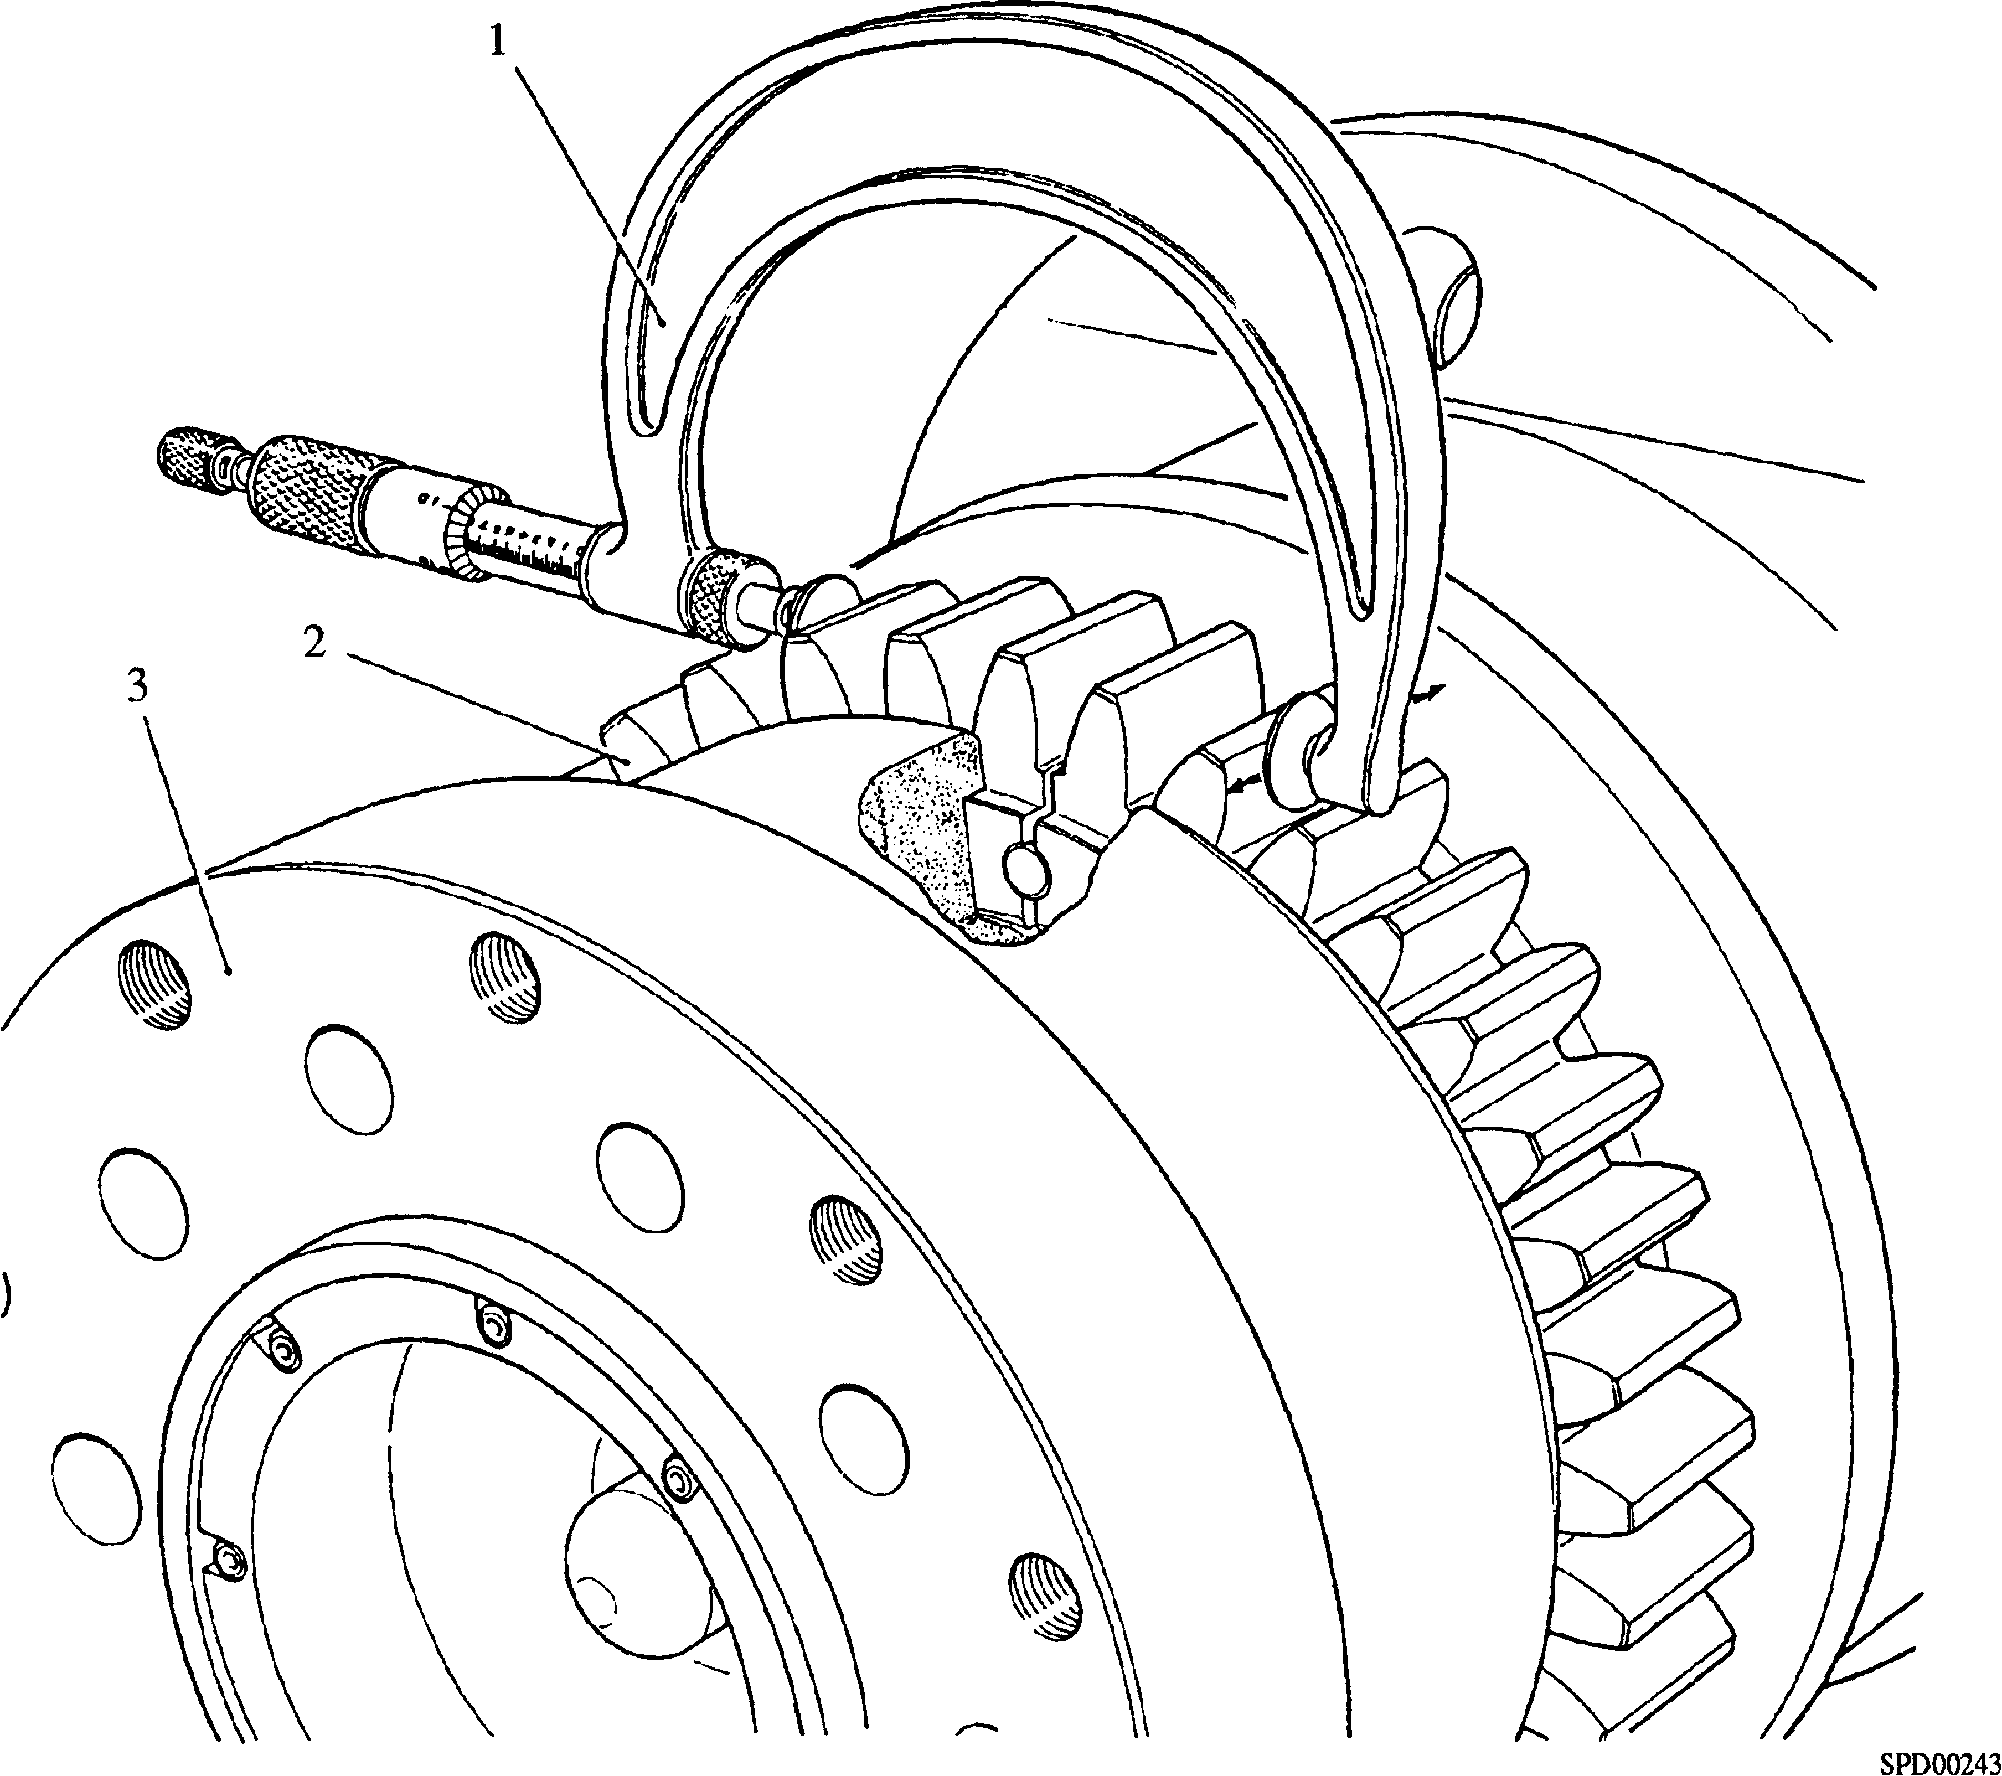

Key to numbers

1. Flange micrometer 3. Crankshaft
2. Drive gear

Fig FF.5 Checking seating of crankshaft gearwheel NOTE All joints and 'O' rings must befitted dry.

The following instructions are based on the assumption that the crankshaft has been completely dismantled to renew damaged or worn parts.

Crankshaft gearwheel. Checking for the matching numbers on each half of the gear, place gearwheel (7)(Fig FF.ll), together with dowels (6) in position, ensuring that the spigot on the gear engages correctly with the recess in the crankshaft. Align the bolt holes, as one of the bolt holes is offset for timing purposes.

1. 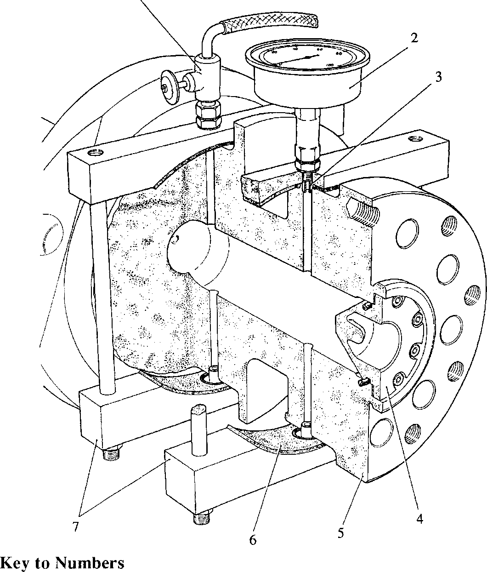Control valve
2. Crankshaft
3. Sealing strip
4. Blanking clamps
5. Pressure gauge
6. Hollow dowel
7. Drive end seal

Fig FF.6 Pressure testing crankshaft drive-end seal

3.3 Fit new dowty washers (35) to fitting bolts (34), apply PolyButylCuprysil (PBC) to the fitting portion of the bolts, and insert into the crankshaft. Tap the bolts through sufficiently to allow philidas nuts (37) to be fitted and then tap fully home. Using the correct crowfoot spanner, tighten the nuts progressively to the torque loading quoted in Section CE.

NOTE The torque loading quoted is the loading at the nut. When using the crowfoot spanner, reduce the torque wrench setting by 8 Ibf ft (11 Nm) to allow for the additional leverage. To ensure that the nuts are not overloaded, it is recommended that the torque wrench/crowfoot spanner combination is checked before use.

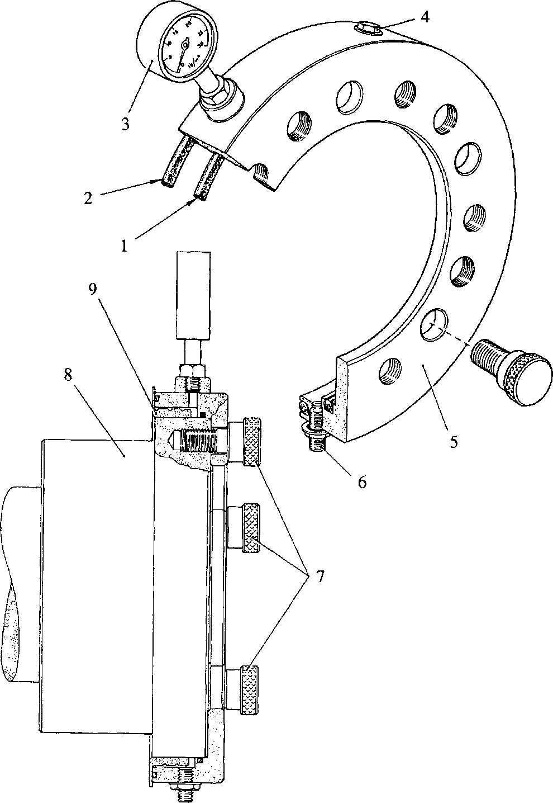Fig FF.7 Pressure testing oil thrower seal

1.

2.

3.

4.

5.

SPD00242

Key to Numbers

'O' ring 'O' ring

Pressure gauge Vent plug Test ring

1. Inlet connection
2. Thumbscrews
3. Crankshaft
4. Oil thrower
5. Carry out the following checks to establish that the gear halves are seated correctly
6. Using a flange micrometer (l)(Fig FF 5) measure across the span of five teeth at each join. Check that the taper over the width of the gear does not exceed 0.013 mm (0.0005 in).
7. Compare the measurements obtained at 3.4.1 above with with any other span of five gear teeth. The difference must not exceed 0.019 mm (0.00075 in).
8. Drive-end oil seal. Fit a new 'O’ ring (12)(Fig FF.ll) and joint (11) to the seal. Insert the seal into the crankshaft and secure with capscrews (10). Assemble blanking clamps (7)(Fig FF.6) to the drive-end journals, locating hollow dowels (3) in the crankshaft oilways. Pressure test the oil reservoir at 7 bar (100 lbf/in2) for 30 minutes. There should be no pressure drop during this time.
9. Stubshaft. Fit new 'O' ring (10)(Fig FF.2) to stubshaft (9) and engage the spigot with the crankshaft. Fit setbolts (8), complete with new locking plate (11), and tighten to the torque loading quoted in Section CE.
10. Facing ring and oil thrower. These items are fitted as part of the free-end cover.

Measuring Main Bearing Bores

1. Thoroughly clean the crankcase, bearing caps and bearing shells. Ensure that the oil drain drillings in the drive-end bearing cap are clear.

NOTE 1 The crankcase half bearing shells are drilled through for lubricating oil transfer, and DO NOT have cutaways at the butt face for location purposes.

1. The edge of the bearing shell with a dowel furthest away from it faces the free-end of the engine.
2. Fit the crankcase half bearing shells ensuring that the station numbers etched on the edge face towards the free-end of the engine. No 1 main bearing is the double width shell at the free-end and is retained by Nos 1 and 2 bearing caps (Fig FF.8).

NOTE The cut-away in drive-end bearing shell (8)(Fig FF.ll) is 'offset' whereas the cutaways in the remainder of the narrow shells are 'central'.

1. Place the bearing shells in the caps, ensuring that the cutaways in the shells align with the recesses for locating keys (16)(Fig FF.ll). Apply a smear of grease to the locating keys to retain them whilst the caps are lowered into position and place them in their recesses.
2. Slide centralising 'O' rings (15) down 'A' bank main bearing studs, positioning them approximately 6 mm from the crankcase butt face.
3. Checking for the station numbers (Fig FF.8), ease each bearing cap into place, adjusting the position of the crankcase 'half shells' as necessary to engage the dowels between the bearing shell halves. Check also that each locating key and 'O' ring is locating correctly. If necessary, crankcase expander (5)(Fig FF3) may be used adjacent to any 'tight' main bearing caps.

NOTE To avoid over expanding the crankcase, only a standard spanner 12 to 14 in long should be used on the spreader. Under no circumstances should any extension be used. Maximum turning moment 108 Nm (80 Ibfft).

1. Referring to Section CE, regarding anti-seize paste application points, fit plain washers and nuts to each bearing cap and 'nip' tight. Fit dowty washers (9)(Fig FF.3) to lateral capscrews (8), insert into the crankcase and screw into the bearing caps. 'Nip' the capscrews and then slacken back one full turn.
2. Fit longitudinal tie bar, flanged dowels, locking plates and setbolts. 'Nip' the setbolts to retain the tie bar in position.

NOTE The torque multiplier required to tighten the main bearing nuts has a reduction ratio of 5:1 and the torque wrench setting must be reduced accordingly. The reaction arm of the multiplier can be allowed to contact the tie bar.

1. Working from the drive-end of the engine, tighten the main bearing nuts progressively to the torque loading quoted in Section CE. Initially a torque wrench only is sufficient, but to bring the nuts to the full torque loading a torque multiplier is required. As each main bearing cap is tightened, check that the capscrews are not binding. When all main bearing nuts are pulled down, return to the drive-end and tighten the capscrews progressively to the torque loading quoted in Section CE.
2. Measure and record the dimensions of the main bearing bores and compare with the actual crankshaft dimensions and, Schedule of Clearances and Wear Limits Section CD.

Fitting Crankshaft.

1. Slacken the lateral capscrews one full turn, then slacken the main bearing cap nuts. Remove the tie bar setbolts, flanged dowels and the tie bar. Remove the lateral capscrews and main bearing cap nuts.
2. 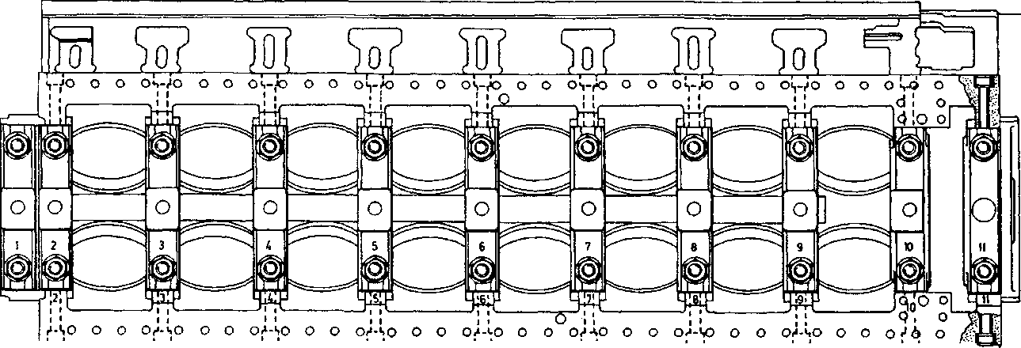Withdraw the main bearing caps carefully so as not to move the crankcase half bearing shells or the locating keys. If necessary use the crankcase spreader (Fig FF.3) adjacent to any 'tight' main bearing caps. Identify the bearing shells if necessary.

FREE

END

m m m a

DRIVE

END

SPD00245

Fig FF.8 Identification of main bearing caps and tightening sequence

1. Fit suitable pieces of rubber or plastic tubing to the free-end and drive-end main bearing studs to prevent damage to them or the crankshaft.

NOTE Crankshaft end float can only be established with 'dry' thrust pads and thrust faces. The presence of oil will cushion the crankshaft and produce inaccurate readings. For this reason a minimum of oil should be applied to the shells of the crankshaft locating bearing consistent with protecting the bearing surface.

1. Clean and oil the bearings and the crankshaft journals.
2. Using a suitable rope sling around Nos 2 and 7 crankpins, lift the crankshaft and lower into position in the crankcase. Check oil sealing ring (13)(Fig FF.l) for clearance and concentricity with the crankshaft 0.10 to 0.19 mm (0.004 to 0.0075 in) with the engine right way up. Peen to secure the screws.
3. Place all bearing caps, complete with bearing shells etc, in position (except the crankshaft locating cap). Referring to Section CE, regarding anti-seize paste application points, fit the plain washers and nuts and 'nip' firmly. Fit the lateral capscrews and dowty washers, 'nip' firmly, and then slacken one full turn.

NOTE 1 The thrust pads fitted to the bearing cap are larger in diameter than the crankcase thrust pads and when in position butt against the crankcase to prevent rotation.

1. Whilst both the wearing surface and the steel backing of the thrust pads may be cleaned up as necessary in order to obtain maximum surface contact, if it should prove necessary to ADJUST the thickness, then material should ONLY be removed from the steel backing.
2. Crankshaft end float. Roll the crankcase half thrust pads into position. Move the crankshaft forcefully in both directions to seat them in their recesses. Using a micrometer clock check that crankshaft end float is within the figures quoted in Section CD. Adjust the thickness of the thrust pads as necessary. Slide the locating bearing cap, together with thrust pads and bearing shell, into position. Fit the lateral capscrews. Check crankshaft endfloat again with the locating cap in position and adjust the thickness of the bearing cap thrust pads as necessary.
3. Releasing individual main bearing nuts if necessary, fit the tie bar, flanged dowels, locking plates and setbolts. 'Nip' the setbolts firmly.
4. Working from the drive-end of the engine, tighten each pair of main bearing nuts progressively to the torque loading quoted in Section CE. Then return to the drive- end of the engine, and tighten the lateral capscrews to the torque loading quoted.
5. Holding the locking plates AGAINST ROTATION, tighten the setbolts to the torque loading quoted in Section CE, and bend up the locking plates.
6. Secure the oil baffle plate to the drive-end main bearing cap with tabwashers and setscrews.

Fitting Drive-end Oil Thrower.

1. Check that oil thrower (4)(Fig FF.9) slides easily on to the crankshaft. High spots may be eased, but DO NOT overwork and cause excessive clearance. Move the crankshaft towards the drive-end of the engine to take up all end float. Degrease the crankshaft and oil thrower using 'Loctite Safety Solvent' or trichloroethane.
2. Apply 'Loctite 648' to the crankshaft. Slide the oil thrower on to the crankshaft with a rotating action to ensure maximum distribution of the 'Loctite', and position as shown in Fig FF.l. A locating tool is available (Fig FF.9), which will ensure correct positioning of the oil thrower. The use of this tool is described below:-
3. Release the knurled nuts to allow hookbolts (3) and (8) to pass over the oil thrower sealing face. Secure the tool to the crankcase using the capscrews provided.
4. Ensuring that all crankshaft end float is taken up towards the drive-end, tighten the knurled nuts evenly to clamp the oil thrower. Remove excess 'Loctite' and allow time to cure.
5. Remove the locating tool and check the oil thrower for 'run out' using a micrometer clock.
   1. Testing 'Loctite' bonding for leaks. Apply a smear of grease to 'O' rings (1) and (2) of test ring (5)(Fig FF.7). Fit the tool to the crankshaft and oil thrower and tighten thumbscrews (7).
   2. Connect a controlled 0.34 bar (5 lbf/in2) compressed air supply to the inlet connection. If a rapid drop in pressure is observed, the oil thrower will have to be removed and refitted as above, but a slow pressure drop can sometimes be remedied by thoroughly degreasing, and using a 0.14 bar (2 lbf/in2) air supply to force a further application of 'Loctite 648' between the oil thrower and crankshaft.
   3. Fit the oil baffle plate to the drive-end main bearing cap and secure with tabwashers and setscrews (Section FH).
   4. Referring to Section JC, fit the lubricating oil pump.
   5. Fit the lubricating oil suction and delivery piping and secure to the main bearing cap tie bar and lubricating oil pump.
   6. Revert the crankcase to its upright position. Referring to Section FH, fit the sump. Mount engine on support legs.
   7. Thoroughly degrease the drive-end cover using 'Loctite Safety Solvent' or trichloroethane and allow to dry naturally. Apply 'Loctite RTV 4' to both contact surfaces of the new 'Vee' seal and press into the cover. Using new joints, fit the drive-end cover and secure to the crankcase with setbolts (2)(Fig FF.l) and plain washers and to the sump with setscrews and plain washers.
   8. Referring to Section FH, fit the free-end cover.
   9. Referring to Section FG, fit the torsional vibration dampers.
   10. Using a new joint fit free-end cover plate.

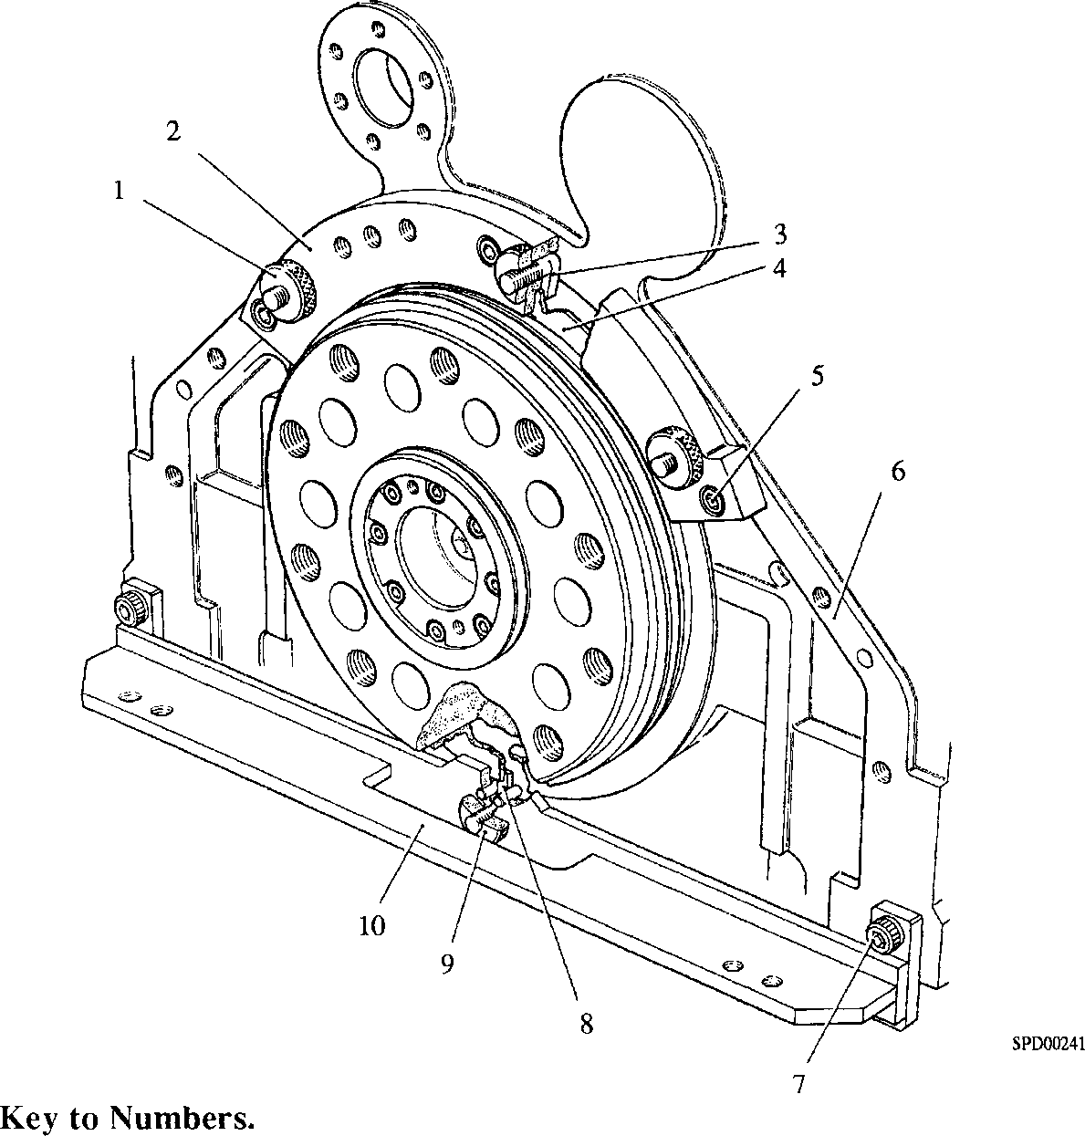Fig FF.9 Positioning oil thrower to crankshaft

1. Knurled nut
2. Upper tool
3. Hooked bolt
4. Oil thrower
5. Capscrew
6. Crankcase
7. Capscrew
8. Hooked bolt
9. Knurled nut
10. Lower tool

Fitting Free-end Oil Seal.

* 1. The position of the 'Vee' seal relative to the facing ring is important in respect of free end oil sealing. This position is controlled by a shim/joint assembly (15)(Fig FF.2) fitted between seal carrier (14) and cover plate (7). The shim is solid and 0.030 in (0.762 mm) thick. To establish joint/shim requirements proceed as follows:-
     1. Measure the distance from the carrier mounting face on the free-end cover plate to the seal facing ring.
     2. For distances 1.0625in + 0.030in (26.98mm + 0.762mm)

- O.OOOin (- 0.000mm)

fit one joint only.

* + 1. For distances 1.0625in + O.OOOin (26.98mm + 0.000mm)

- 0.030in (- 0.762mm)

fit two joints and one shim.

* 1. Fit a new 'Vee' seal (13)(Fig FF.2) to seal carrier (14). Place joint/shim assembly (15) in position. If fitting two joints and one shim, place the shim between the joints.
  2. Fit the seal carrier to the free end cover plate, ensuring that the oil drain connection is at the bottom, and secure with philidas nuts (5) and plain washers.
  3. Using new dowty washers, fit oil drain pipe (3), between the seal carrier and the free-end cover.
  4. Complete reassembly of engine in accordance with appropriate Sections.
  5. For setting of speed perception head to flywheel stud see Section CB.

CHAPTER 4

CRANKSHAFT ALIGNMENT

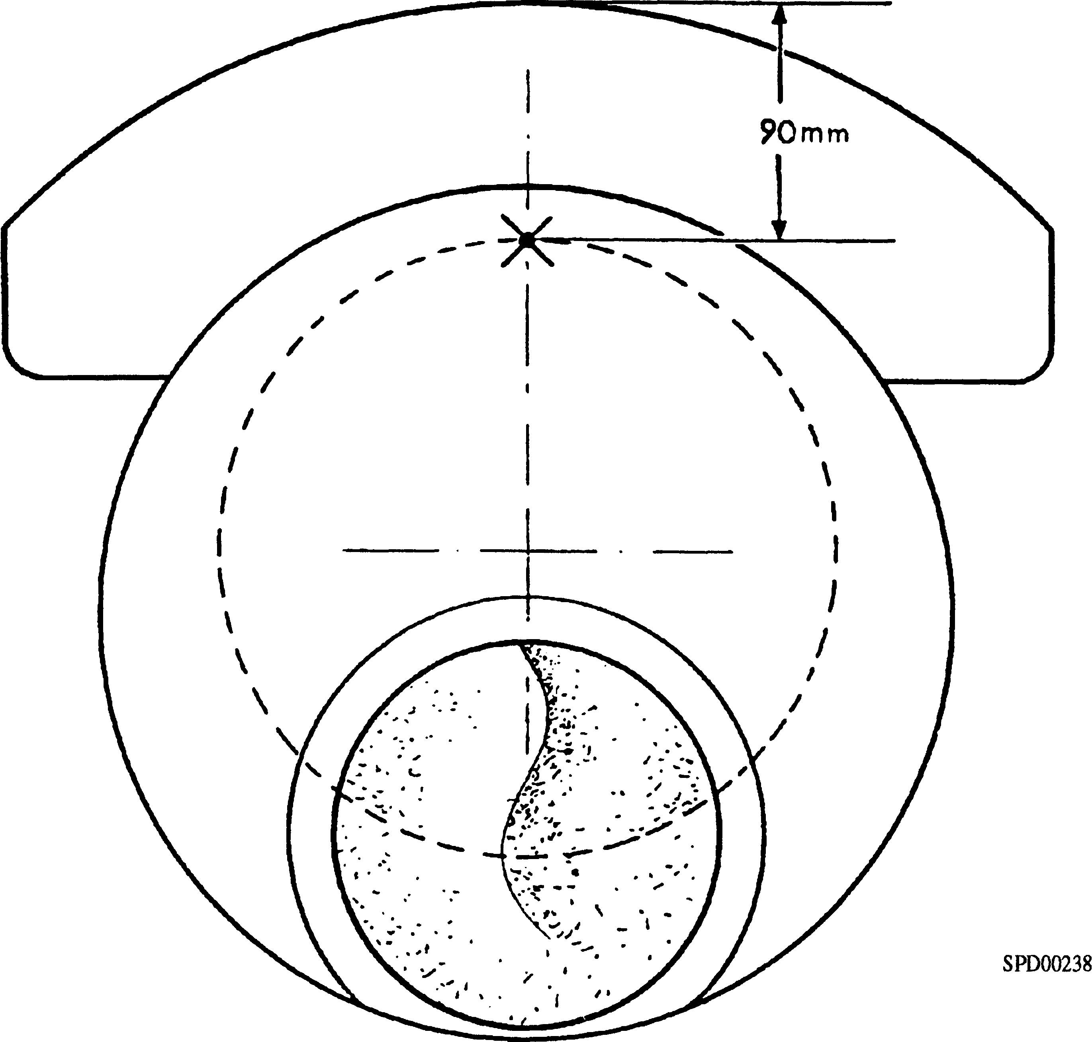

Fig FF.10 Position of crankshaft alignment indicator

1. As a crankshaft is rotated, any misalignment of the driven unit will tend to deflect the crankshaft causing the crankwebs to open and close. These deflections can be measured simply and accurately using a special dial micrometer (crank-clock) positioned as shown in Fig FF.10.
2. During initial installation satisfactory alignment of the driven unit to engine crankshaft will have been established and deflections for each 'throw' of the crankshaft taken and recorded. It must not be assumed that this alignment will be maintained indefinitely. After a period of running, certain conditions may develop which could cause excessive deflections and if such conditions are allowed to persist, the crankshaft may eventually fracture due to fatigue.
3. Excessive deflections can usually be attributed to one or more of the following conditions:-
4. Shaft of driven unit out of line with engine crankshaft in either vertical and/or horizontal planes.
5. Gross variation in the loading of the flexible mountings which can be caused by deterioration and 'shake-down' of the mountings or by misalignment of the seatings supporting the combined set.
6. Excessive clearances in crankshaft main bearings.
7. Dowels or other locating devices for engine or driven machine becoming loose.
8. Over tightening of drive belts to auxiliaries such as seawater pumps, etc.
9. Crankshaft deflections are usually measured at the drive-end of the crankshaft where the most serious deflections are to be expected. After a period of service, deflections at other crankwebs should also be taken to ensure that total alignment is being maintained, and in particular after the free-end drive belts have been tensioned.
10. To ensure that the flexible mountings supporting the engine and driven unit are carrying their normal weight. Crankshaft deflections should only be taken with the coolant spaces filled, and the lubricating oil sump filled to the 'MAX' mark on the dipstick.

To Check Crankshaft Deflections.

1. Prime the system to provide lubrication. Cease priming and allow the surplus oil, which could obscure the crank-clock, to drain away.
2. Remove the crankcase doors from the relevant crankshaft position. If the drive-end throw is to be checked, it may be necessary to remove the starter motors to gain access.
3. Bar the crankshaft round to position the crankpin horizontal towards 'B' bank, and insert the crank-clock. Positioning of the crank-clock is important; it should be placed opposite the crankpin in a position corresponding, as near as possible, to the outer diameter of the main bearing journal. The correct position is shown in Fig FF.10. If the engine is warm, leave the indicator in position for a few minutes to assume the temperature of the crankshaft.
4. Bar the crankshaft round in the direction of rotation as far as possible until the crank-clock is almost touching the connecting rod. Set the dial to Zero.

NOTE 1 As the connecting rods are not dismantled it is not possible to take a reading with the crankpin at Vertical Bottom Centre ’VBC'. Readings should however, be taken as close as possible either side of 'VBC\ Great care must be taken when approaching this position to prevent the connecting rod contacting the crank-clock, as this would push it out of the crankweb into the sump.

1. The crank-clock must not be disturbed whilst readings are being taken and must not be rotated after initial setting. For this reason a small illuminated mirror will be necessary for observation of the dial in certain positions.
2. Bar the crankshaft round in the opposite direction so that the crankpin passes through Vertical Top Centre 'VTC', taking readings when the crankpin is at 'VTC'. The horizontal positions towards 'A' and 'B' banks, and as close as possible to the Vertical Bottom Centre (VBC) towards 'A' bank.
3. The deflection is given by the greatest difference between any two readings, eg, if the extremes recorded are 0.038 mm (0.0015 in) and -0.013 mm (0.0005 in) then the deflection is 0.051 mm (0.002 in).

Maximum Permissible Deflections.

1. For a new or overhauled installation the variation between indicator readings should not exceed 0.066 mm (0.0026 in). It should be noted that this figure is an absolute maximum, and it should always be the aim when aligning a set to achieve the smallest possible crankshaft deflection.
2. The maximum permissible variation between indicator readings after a period of service is 0.091 mm (0.0036 in), at which stage the engine must be withdrawn from service for re-alignment or overhaul.

CHAPTER 5

CRANKPIN BORE SEALING CUPS

1. At major overhaul periods or if it is required to flush the crankshaft after regrinding, the crankpin bore sealing cups will require removal to clean out the oil drillings before reassembly.

To Remove (Fig FF.I2)

1. Insert the drill bush (1) into sealing cup (6), drill through the bottom of the sealing cup. Remove the drill bush and tap the hole M10.
2. Place jacking tool (4) on the crankpin and tighten clamp bolt (8) sufficiently to retain the tool in position. Screw in hydraulic ram (3) until the anvil contacts the bottom of sealing cup (6), adjusting the position of jacking tool (4) on the crankpin to obtain optimum alignment. 'Nip up' clamp bolt (8), but do not overtighten; it is not necessary to close the clamp completely.

NOTE One full stroke of the tool, ie the complete thread of centre screw (2), is all that is required. Additional travel will merely 'jam' the cup in the narrower portion of the bore.

1. Operate the tool to push the sealing cup down the bore thus collapsing the expanded portion of the cup to approximately the original diameter.
2. Unscrew and remove hydraulic ram (3) from jacking tool (4). Extract the sealing cup with extractor tool (7), using the jacking tool as a strong back.

To Replace

1. Clean and inspect the sealing cups and the crankpin bores.
2. Place sealing cup (6) into the crankpin bore with oil hole (10) uppermost. In this position the oil hole will prevent a build up of carbon in the bore caused by the centrifugal action of the crankshaft.
3. The procedure for selection of collars for dolly assembly (18) is as follows:-
4. For crankshafts with a l3/t in x IV2 in deep blind hole bored into the side of the crankpin opposite the crankpin seals, collar (15) with 27V20 taper. The exception is the drive end crankpin web (No 6) which will require the use of collar (13) with 35° taper.
5. For crankshafts without the blind hole, use collar (14) with 36° taper.
6. Drive the sealing cup 'fully home’ using the correct dolly assembly(18). Remove the dolly assembly.
7. The crankweb cutaway on the drive-end crank throw is not at right angles in relation to the bore and an angled tool assembly is required to expand the sealing cup.
8. The procedure for selection of collars for expanding tool (20) is as follows:-
9. For crankshafts with a l3/4 in x IV2 in deep blind hole bored into the side of the crankpin opposite the crankpin seals, collar (15) with 27V20 taper. The exception is the drive end crankpin web (No 6), which will require the use of collar (16) with 35° taper.

LIMITED RIGHTS LEGEND

USE, DUPLICATION OR DISCLOSURE OF THIS INFORMATION WHICH IS THE PROPERTY ^ 1

OF GEC ALSTHOM DIESELS LIMITED BY THE U.S. GOVERNMENT OR BOLLINGER IS & k

SUBJECT TO THE RESTRICTIONS SET FORTH IN DOD FAR SUPP 252.227-7013 (a) 15.

1. For crankshafts without the blind hole, use collar (14) with 36° taper.
2. Coat the contact surfaces of expanding tool (20) and appropriate collar (19) with PolyButylCuprysil (PBC) and insert the tool into the sealing cup. Check that the shoulder of the tool collar is flush against the crankweb as shown. Rotate the tool in a clockwise direction whilst progressively tightening the nut on the centre spindle, so forcing the balls outwards and expanding the wall of the sealing cup into the groove in the crankpin bore. Release the centre spindle nut and remove the expanding tool.
3. Clean away all traces of PBC from the sealing cup. Check that the oil hole has remained in the correct position. Locate position gauge (9) into the expanded bore of the sealing cup, and check that the edge of the crankshaft bore falls between the maximum and minimum steps on the shoulder of the gauge.

CHAPTER 6

FITTING OF SPLIT STARTER RING

3

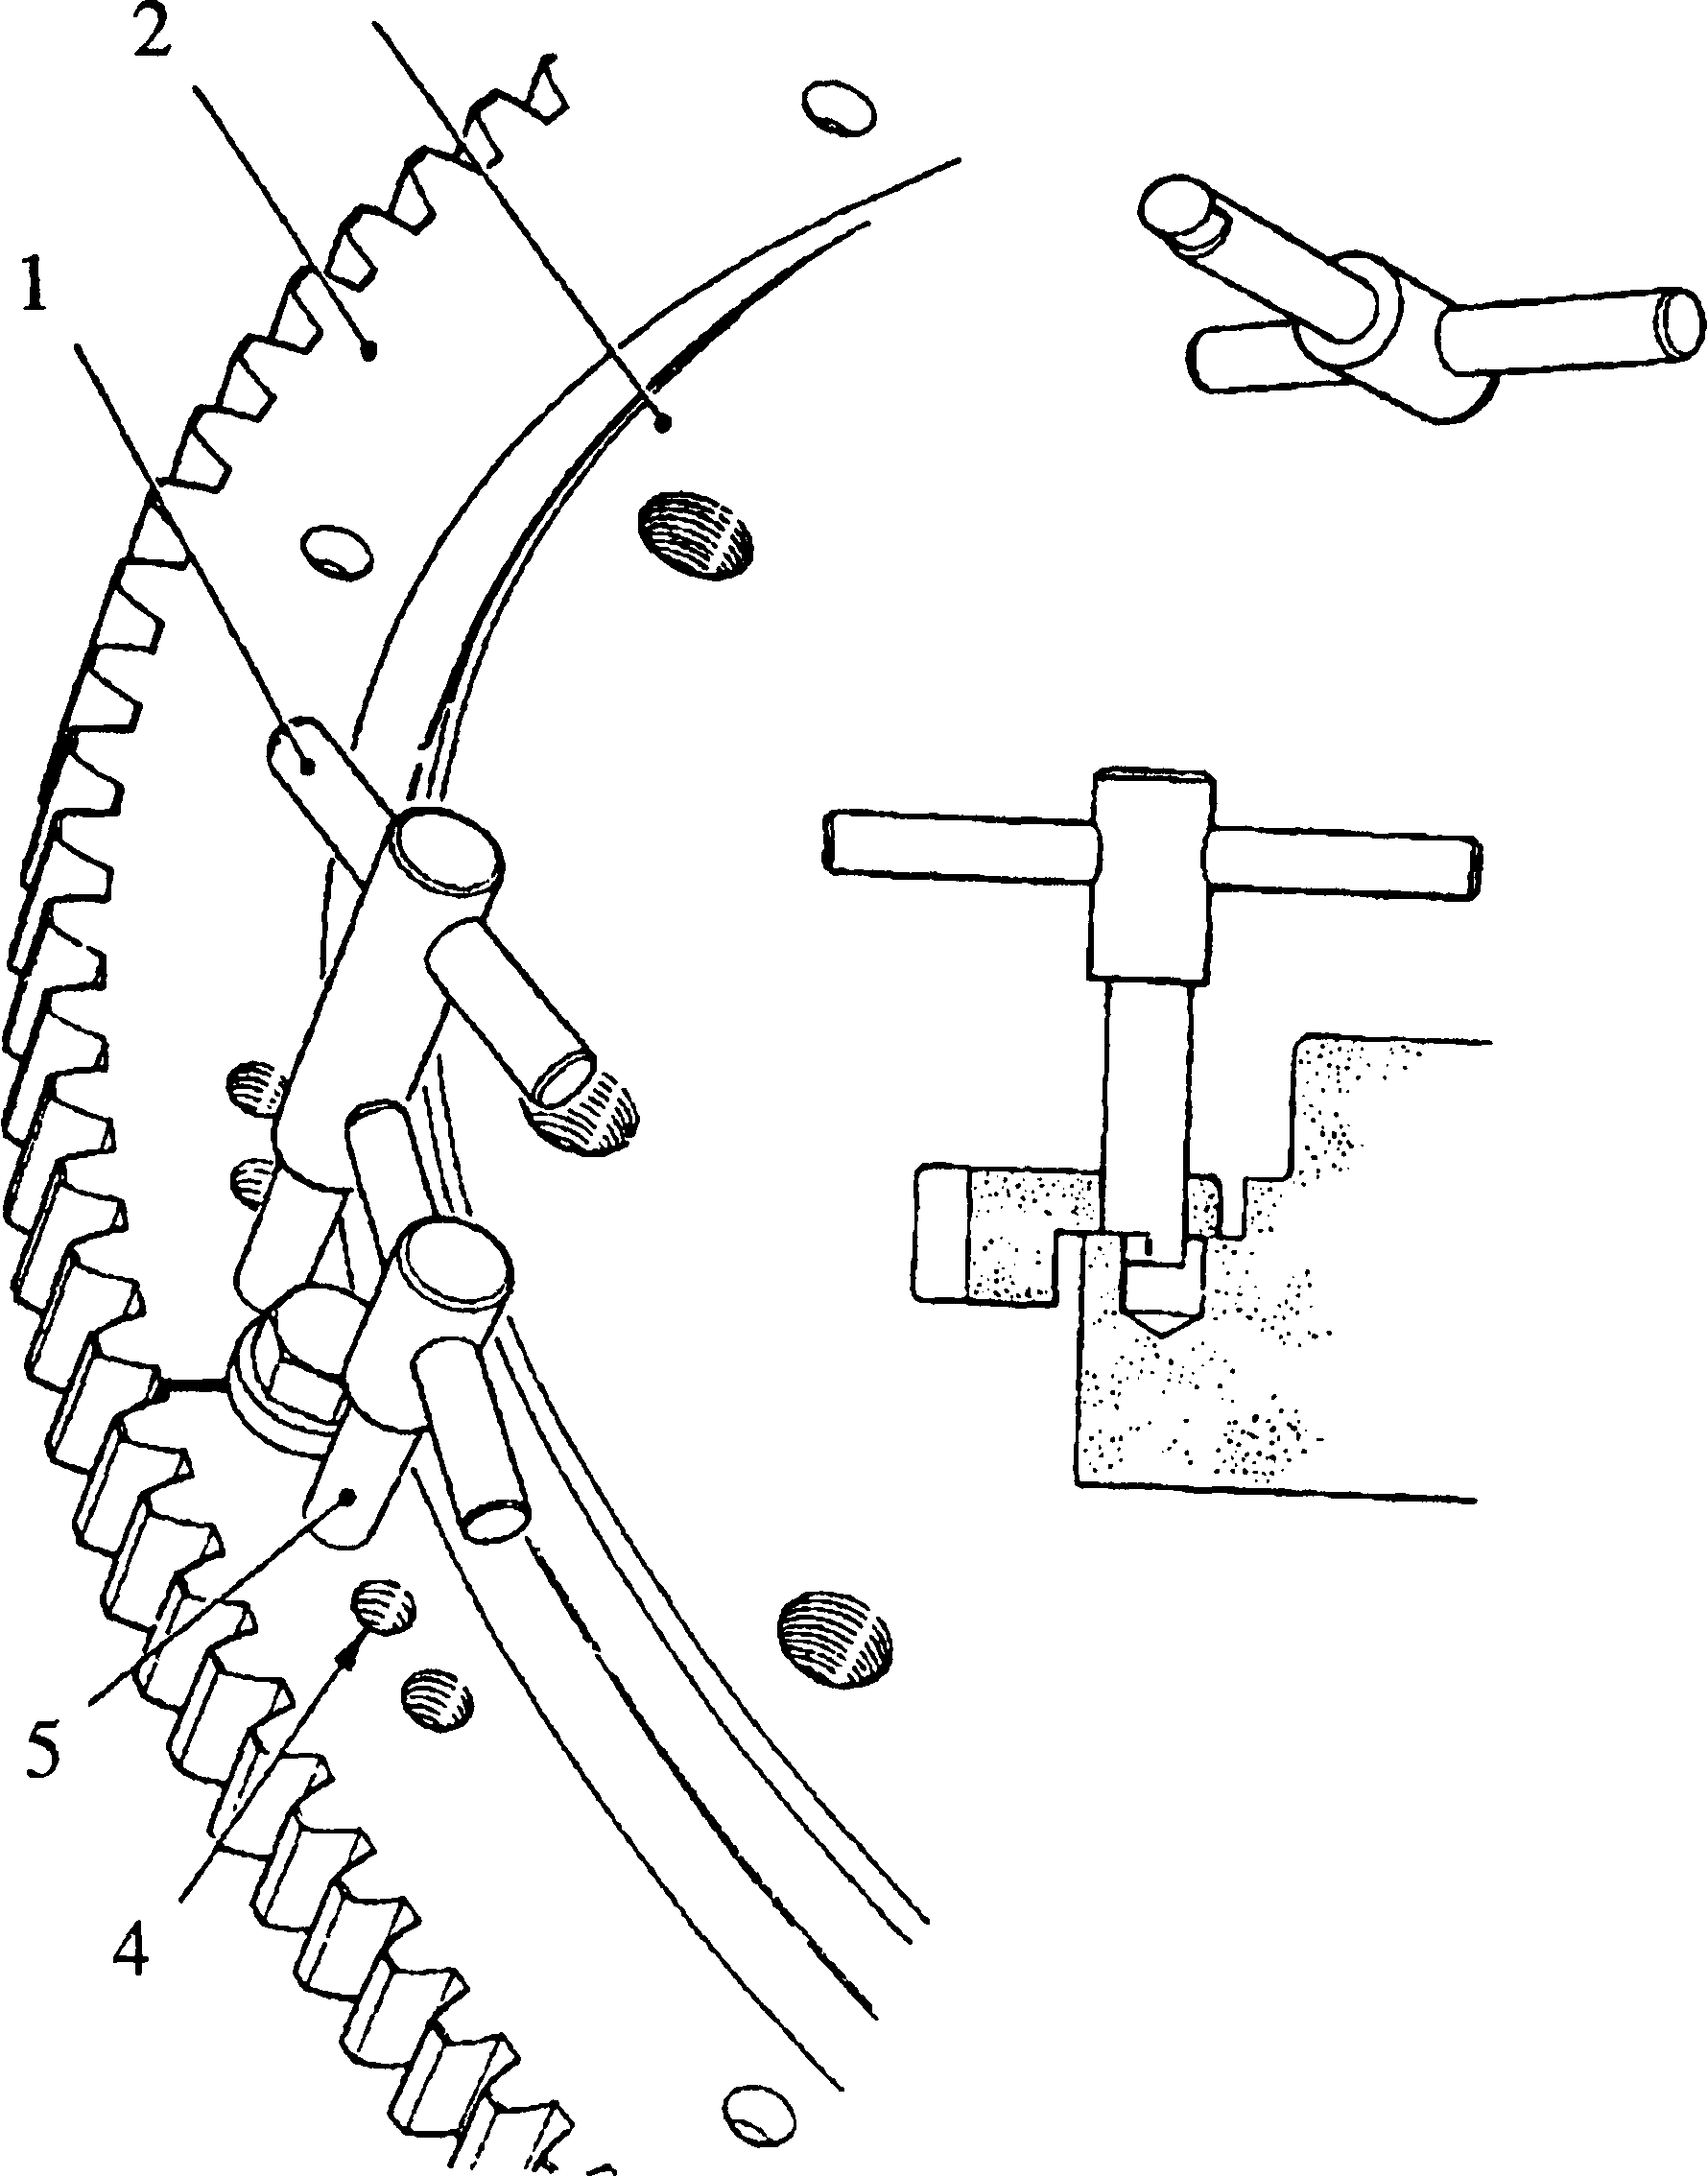

SPD00247

Key to Numbers.

1. Cam end location tool, long 4.

Jacking screw hole

Cam end location tool, short

1. Starter ring gear 5.
2. Flywheel

Fig FF.ll Cam end location tools, starter ring to flywheel

1. On removal, due to the residual hoop stress in starter rings, the starter ring halves open at the 'horns' when the rings are split. In order to pull the rings back into shape when they are fitted to the flywheel a pair of tools having eccentric cam ends are required (see Chapter 7).
2. The following method is used when refitting the starter ring:-
3. Remove all fastenings. Check the flywheel/starter ring mating faces for burrs, cleaning if necessary.

NOTE The dowel holes in one of the starter ring gear halves are offset by J/i6 in from the PCD of the remaining setscrew holes.

1. Checking for the ring gear half with offset holes and the corresponding offset holes in the flywheel, offer up the ring gear to the flywheel and temporarily fit plain washers and setscrews where possible.
2. Insert both tools (Fig FF.ll) into the dowel holes either side of one of the butt joints and locate them into the flywheel dowel holes. One tool is longer to prevent fouling of the handles in operation.
3. Rotate the tools through 180° to pull the starter ring 'horns' into circular form. Fit and 'nip up' adjacent setscrews firmly. Repeat for opposite side of starter ring.
4. Using feeler gauges check the starter ring for concentricity with the flywheel. Slight adjustment is possible by tapping the ring with a soft-face mallet. Tighten the setscrews to a torque loading of 68 Nm (50 lbf ft).
5. Fit the dowels. Remove the setscrews, no more than two at one time, discard the plain washers and refit with locking plates. Retighten each pair of setscrews to the correct torque loading.
6. Re-check for concentricity. Lock the setscrews by bending up the locking plates. Only two of the dowels are retained by the locking plates; the remaining two dowels are retained by centre-punching starter ring material over the dowels.
7. Check starter motor/flywheel pinion lead and backlash (section N A).

CHAPTER 7

SPECIAL TOOLS

The following special tools are sufficient for carrying out all general maintenance, dismantling, overhaul and assembly operations on the crankshaft as detailed in this section.

NOTE These tools are only shown in the Illustrated Parts List if they if they have been ordered as part of the contract.

|  |  |  |  |  |
| --- | --- | --- | --- | --- |
| DESCRIPTION | | PART NO | USE | |
| Torque wrench 0 to 50 lbf ft | | OD26977 | To tighten fastenings to pre-determined loadings | |
| Torque wrench 50 to 250 lbf ft | | OD28465 | To tighten fastenings to pre-determined loadings | |
| Torque multiplier (Ratio 5:1) | | OD28450 | To increase the effective torque, of torque wrench for main bearing nuts | |
| Adaptor V2 to 3A |  | OD28446/04 | To provide drive between torque wrench and torque multiplier | |
| 46mm A/F socket |  | OD28371/06 | To remove and tighten main bearing nuts | |
| 17mm A/F socket |  | OD28371/01 | To provide drive for hexagon bit | |
| Crowfoot spanner |  | Y3J70769 | To remove and tighten crankshaft gear nuts | |
| Turning out tool  Crankcase Expander |  | Y3J70010  Y3J70836 | To turn the crankshaft-half bearings out of their housings before removing the crankshaft  To assist removal of main bearing caps | |
| Crank-clock |  | ST034860 | To measure crankshaft deflections | |
| Test ring |  | A1688 | To test Loctite bonding of drive-end oil thrower | |
| Adaptor |  | T10066M | Checking torque loading of crankshaft balance weights | |
| Blanking clamps |  | A2057 | To test sealing of crank-shaft drive-end seal. | |
| Locating tool-upper |  | T10369 | To position drive-end oil thrower | |
| Locating tool-lower |  | T13489 | To position drive-end oil thrower | |
| Hexagon bit |  | OD2508 | To provide drive for lateral capscrews | |
| Dolly Assembly Comprising:- Dolly  Collar, Dolly 35°  Collar, Dolly 27Vi°  Collar, Dolly 36° | | Y3J72901  Y3J72922  Y3J72923  Y3J72923A  Y3J72923B | )  ) For fitting crankpin bore sealing cups )  )  ) | |
|  | LIMITED RIGHTS LEGEND  USE, DUPLICATION OR DISCLOSURE OF THIS INFORMATION WHICH IS THE PROPERTY OF GEC ALSTHOM DIESELS LIMITED BY THE U.S. GOVERNMENT OR BOLLINGER IS SUBJECT TO THE RESTRICTIONS SET FORTH IN DOD FAR SUPP 252.227-7013 (■) 15. | | | 25 |

|  |  |  |
| --- | --- | --- |
| DESCRIPTION | PART NO | USE |
| Expanding Tool Comprising:- Collar, Tool 36°  Collar, Tool 21x/i°  Collar, Tool 35°  Jacking Tool Comprising:- Jacking Tool  Extraction Tool  Drill Bush  Position Gauge | Y3J72902  Y3J72926  Y3J72926A  Y3J72926B  Y3J72820 | )  ) For expanding crankpin bore sealing ) cups )  )  ) For removing crankpin bore sealing ) cups )  ) |

Key to Numbers. (Fig FF.ll):-

1. Crankshaft
2. Main bearing shell - top half (free end only)
3. Crankshaft balance weight
4. Main bearing shell - top half
5. Thrust washers
6. Dowel for gear halves
7. Drive gear halves
8. Main bearing shell-top half (drive end only)
9. Drive end seal
10. Capscrew
11. Joint
12. 'O' ring
13. Main bearing shell-bottom half (drive end only)
14. Main bearing shell-bottom half
15. Centralising 'O' ring
16. Locating key
17. Main bearing shell-bottom half (free end only)
18. Damper mounting face
19. Hole for jacking screw-tapped M16
20. Facing ring
21. Setscrew
22. Locking plate
23. Stubshaft
24. 'O' ring
25. Cover plate
26. 'Vee' seal
27. Capscrew
28. Dowel
29. Oil hole
30. Seal
31. 'Vee' seal
32. Oil thrower
33. Drive end cover
34. Fitting bolt, drive gear to crankshaft
35. Dowty washer
36. Hole for jacking screw-tapped M8
37. Philidas nuts

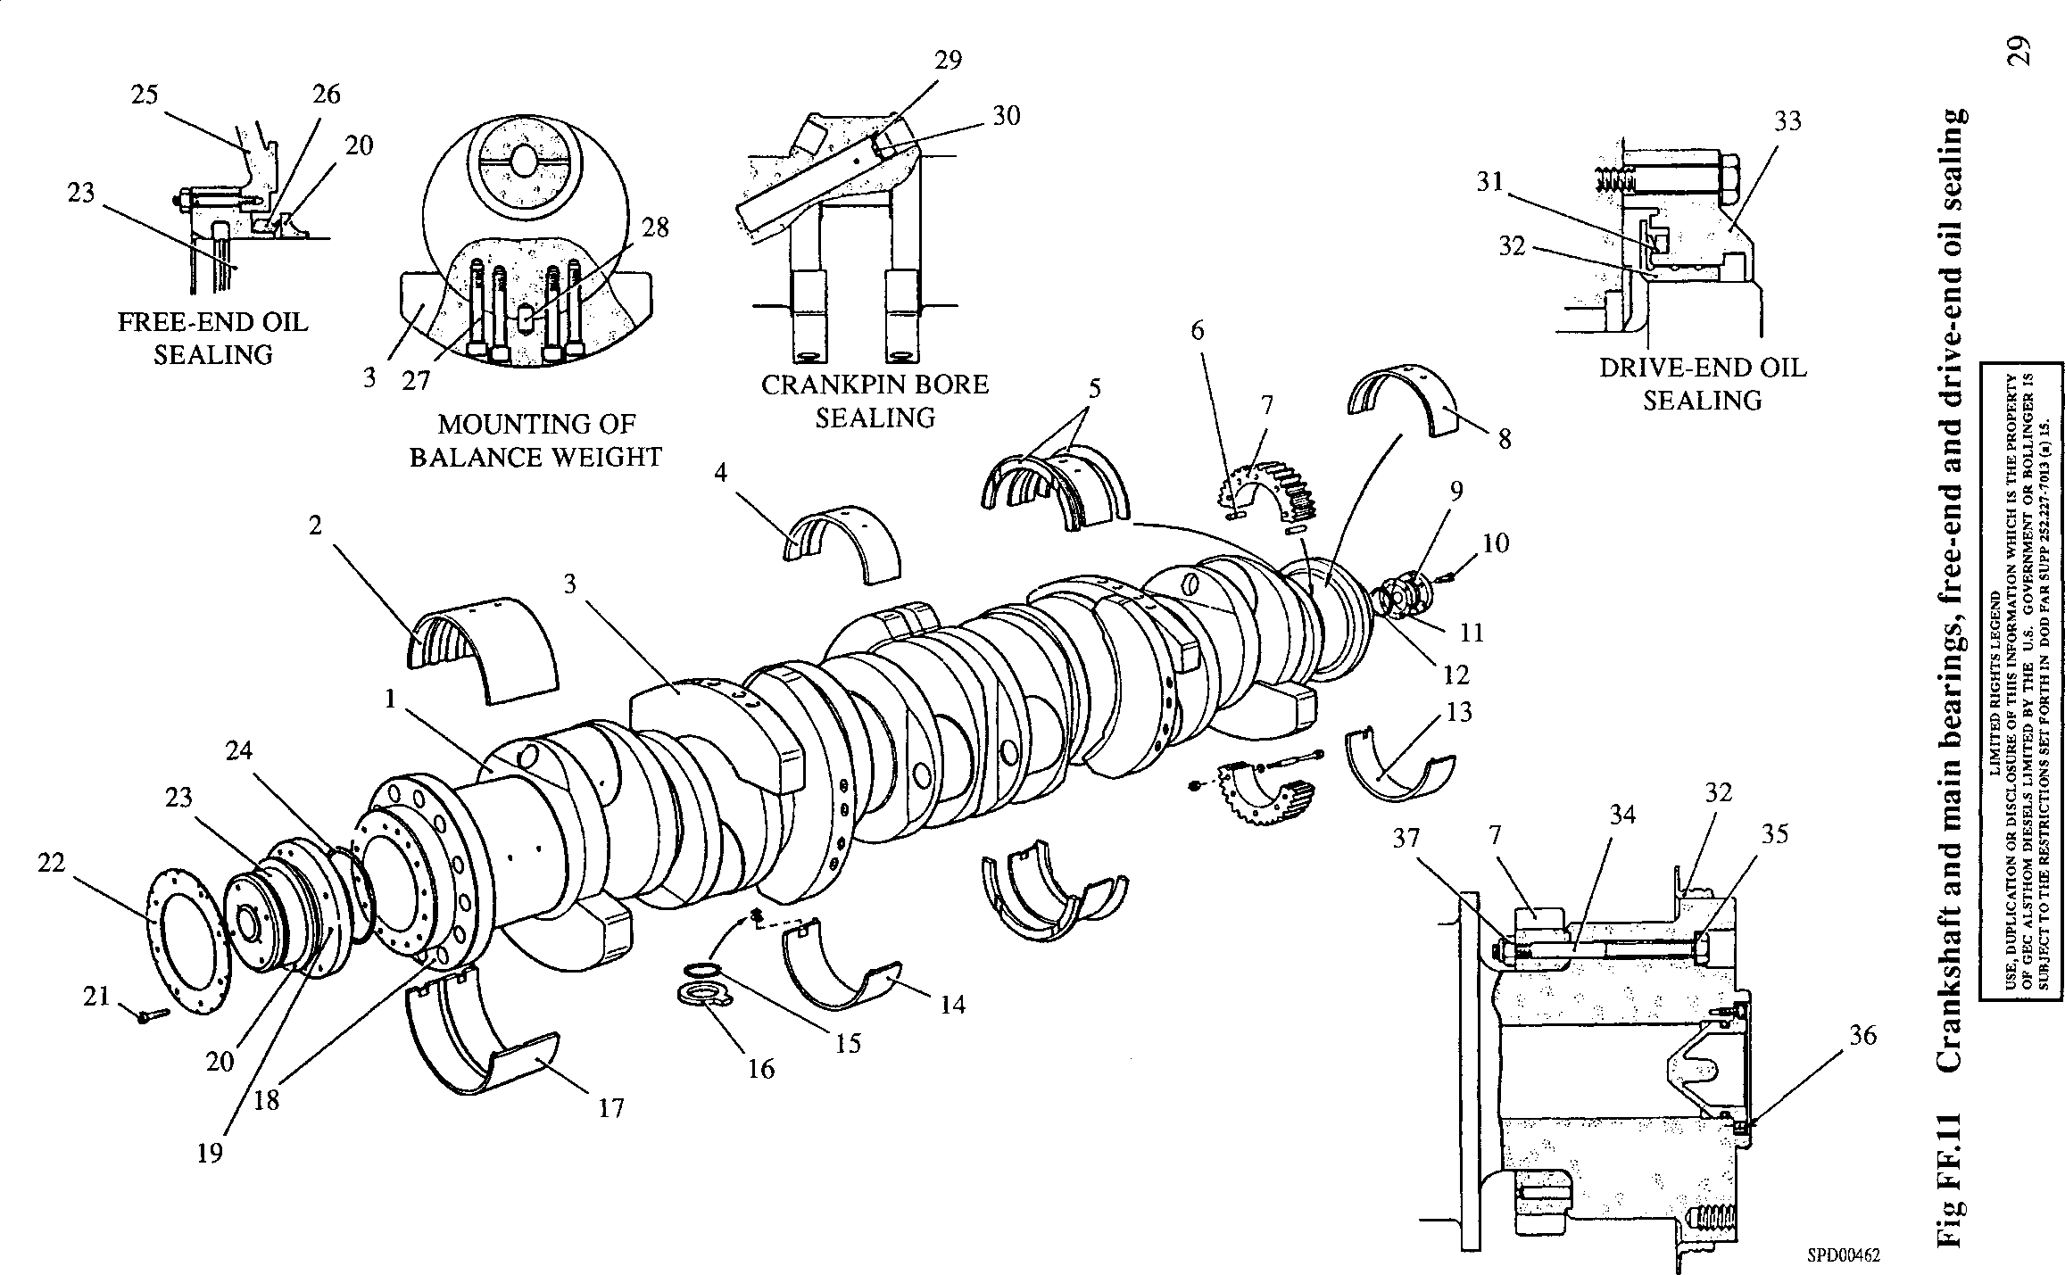

200FF022

**SECTION THROUGH DRIVE-END  
OF CRANKSHAFT**

Key To Numbers

1. Drill bush
2. Centre screw
3. Hydraulic ram
4. Jacking tool
5. Anvil
6. Sealing cup
7. Extractor tool
8. Clamp bolt
9. Position gauge
10. Oil hole
11. Collar 36° for expanding tool
12. Collar 27V2°for expanding tool
13. Collar 35° for expanding tool
14. Collar 36° for dolly
15. Collar 27V2° for dolly
16. Collar 35° for dolly
17. Collar for dolly (fitted position)
18. Dolly
19. Collar for expanding tool (fitted position)
20. Expanding tool

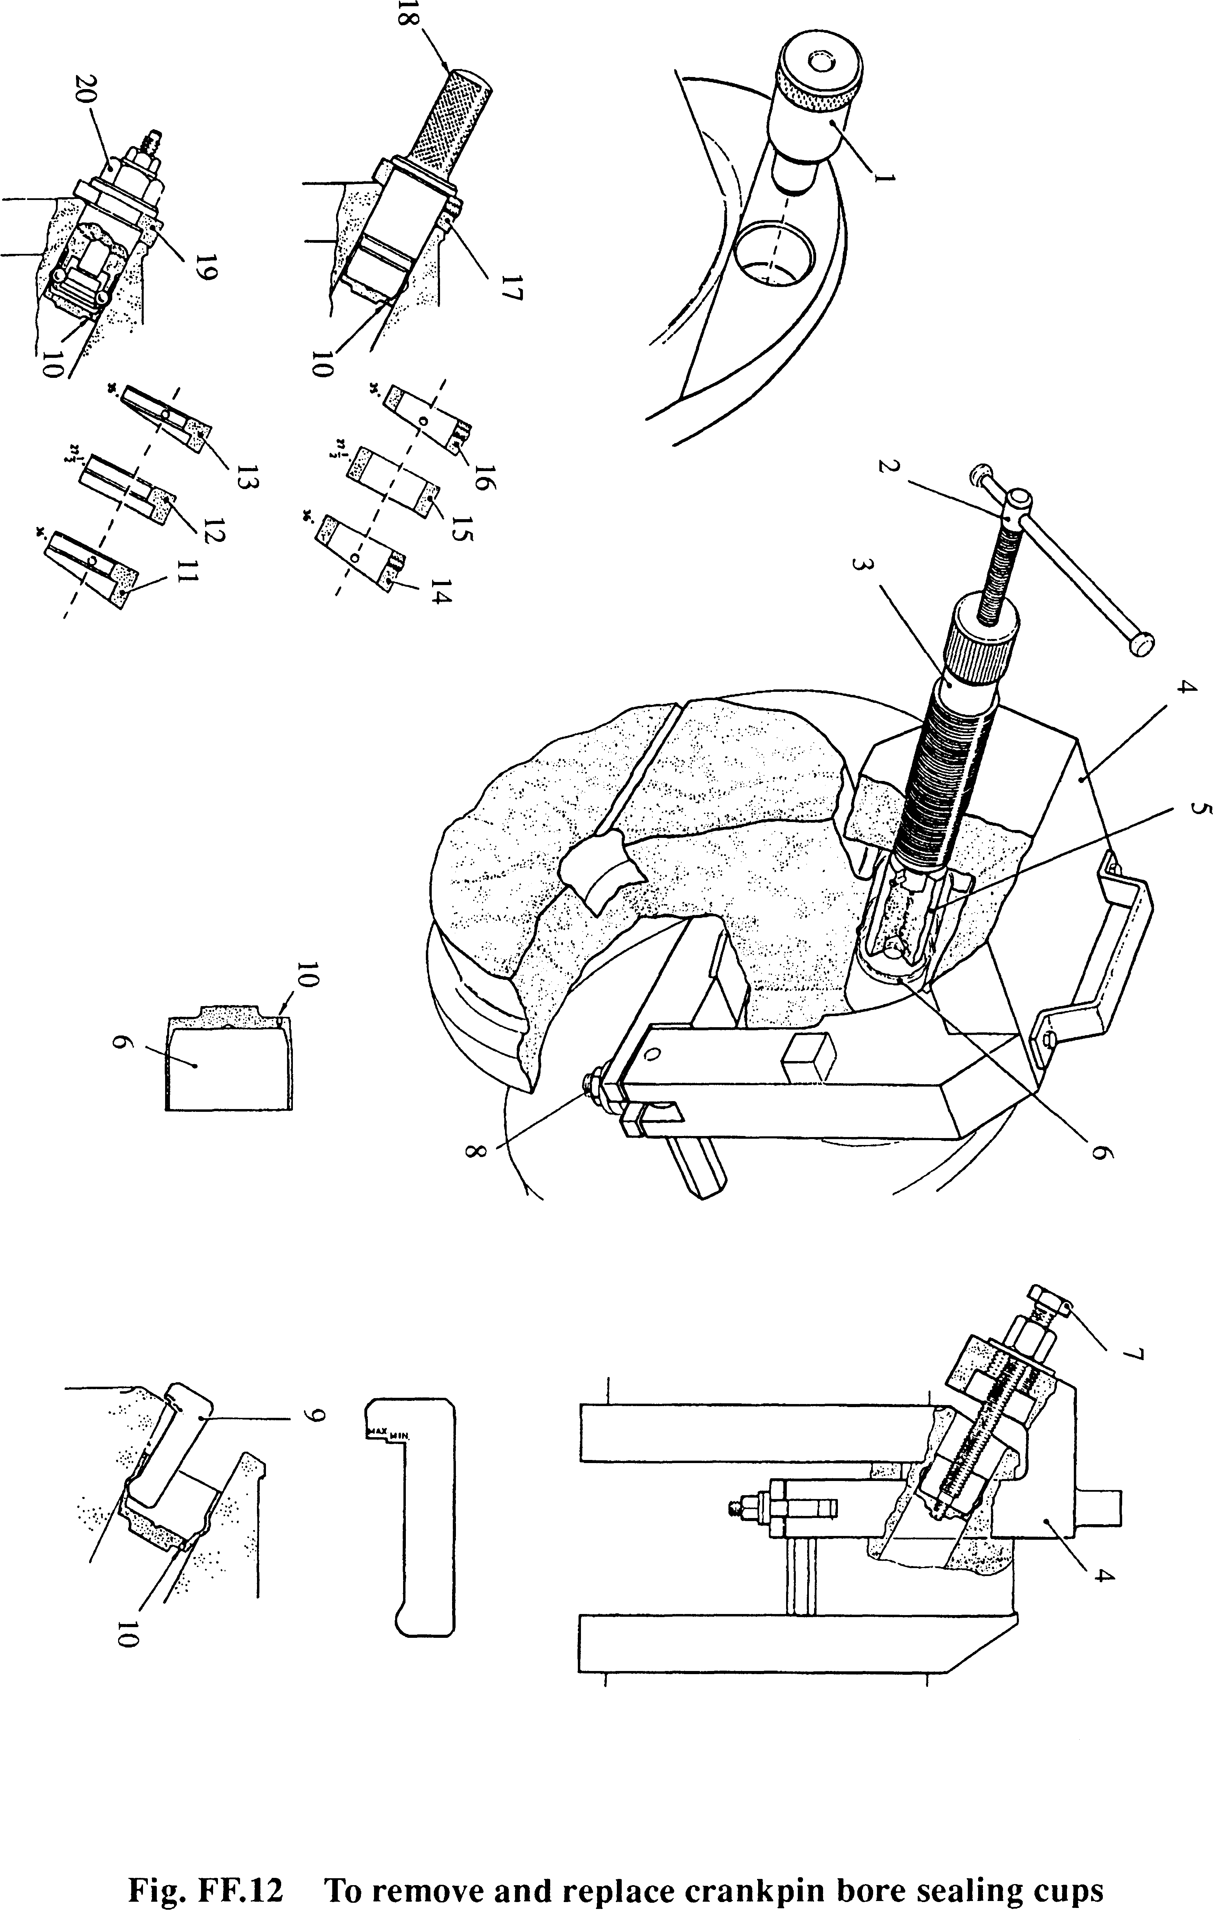

SPD00246